1. THE COMPANY AND THE PRODUCT
   1. OVERVIEW

The risk factor is defined as including multiple factors, namely the ingestion of

unsafe water, lack of water linked to inadequate hygiene, poor personal and

domestic hygiene and agricultural practices, contact with unsafe water, and

inadequate development and management of water resources or water

systems. In many developing countries, dirty or contaminated water is being

used for drinking without any proper former treatment. One of the reasons

for this happening is the unawareness of public and administration and the

lack of water quality monitoring system which creates serious health issues

Also natural phenomena such as volcanoes, algae tints, rainstorms, and

earthquakes also change the quality and ecological status of water.

JAB’s Inc. was founded in the Mandaue City, Cebu, Philippines last March

2019. With our CEO Bernard Panares and co-partnership Jucel Gadiano and Ahrve

Jabonillo. The team had created the Arduino Based Water Quality Tester to offer in

Any company and market who wants to have a comfortable and affordable

water quality tester and this project is an portable that easiest to use to those who

want to buy in the market or online shopping.

* 1. BUSINESS MODEL

The business model that is use in this project is the business to consumer model.

Business to Customer sometimes refers to the tactics and strategies in which

a company promotes its products and services to individual people: creating,

advertising, and selling products for customers to use in their everyday lives.

The target of the company for this business is the places that have polluted water

which might be contaminated and it is not safe for drinking water but the main

target of this project is the hikers, mountain climbing, bikers, and campers.

* 1. THE PRODUCT

JAB Inc. will offer the first portable water quality tester. We created “Arduino

Based Water Quality Tester” in terms of water tester, where that you can test the

quality of water using this portable or tumbler where that the result will appear

in screen after you test the water. It also tests the safeness of water so that you

can test the water for safe to drink or not safe to drink. This project has more

features to test the water.

1.4 THE PRODUCT VALUE

Here in Cebu, there is a lot of unclean water, such as rainwater, in the river, in

the well. and because of this, many people get sick from drinking contaminated

water and there are areas where there is no technology to purify the water

before drinking it. And some tourists like adventure such as hikers, mountain

climbing, bikers and campers and sometimes they want to drink water in the

river, lake, etc. But we don't know if the water they drink is safe to drink.

But with the JAB Inc. very own a technology the “Arduino Based Water

Quality Tester”, The design of our project is tumbler or portable. Places here in

Cebu that has contaminated water have a solution to test the water so they can

use our project to test the water if safe to drink or not. And it's useful to

adventurers, for a reason this project is portable and easy to use for the

adventurers. So if they want to use this project they need to put water in

tumbler afterward it ill appears on the screen if the water is safe to drink or not.

If they want to drink in a river, lake or places that have contaminated water.

1.5 MARKET ENTRY AND GROWTH STRATEGY

Water quality is expected to deteriorate quickly over the next few decades,

increasing hazards to human health, financial growth and thousands of aquatic

ecosystems in both developed and developing economies. This has led to

governments all over the globe to take preventive measure to avoid water

shortage and water contamination contingencies, in collaboration with private

corporations.

The team will be using Social Medias, Newspapers and advertisements to

promote and enforce our product value. The company also plan to expand not

just here in VISAYAS but in whole Philippines next year.

2.0 MARKET RESEARCH AND ANALYSIS

2.1 MARKET DEFINITION

JAB Inc. is target market are the company that related to the water supply.

Research state that there are up to 1.5 million adventurers who visit Cebu last

year 2018 itself and 39% of the adventurer are having hard time to get a proper

drinking of water, updated and secure information to get their needs like how to

taste the water if safe to drink. So our product is fit in this situation for a reason

our project is portable and affordable.

2.2 RESEARCH METHODOLOGY

  The researchers gather data through testing, user reviews, and questionnaire.

Water quality tester methodology that can be applied either on a regional basis

or to site-specific, alternative approaches to monitoring the quality of water at a

considerable saving of time and money. Extensive detail is given to the relation

of water quality to the geohydrology framework, constituents in the polluted

water, sources and causes of pollution, and the use of water.

2.3 MARKET SIZE

Hikers, mountain climbing, bikers and campers is the main target of JAB Inc.

Water supplies could also benefit from the $2.7b allocated to groundwater

storage projects.

Will be generated for the next 4 years in developing educational field and $7.5b

in developing retail which the “Arduino Based Water Quality Tester” fit.

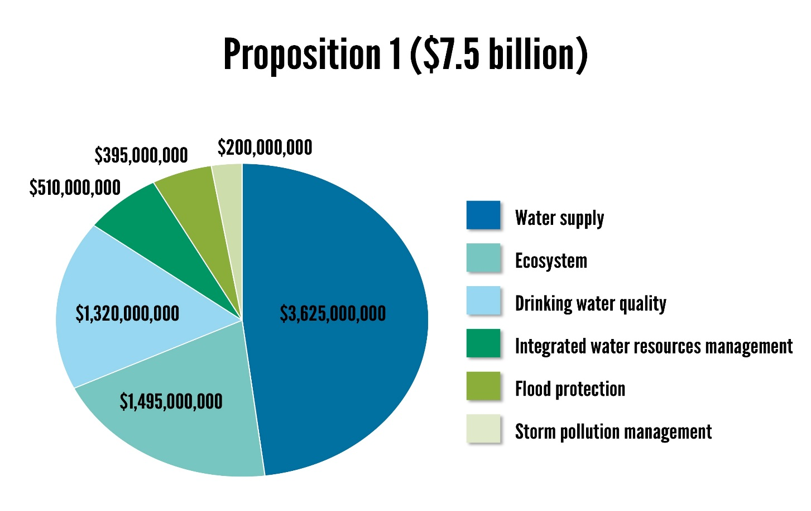

2.4 MARKETING STRATEGY

JAB Inc. will be promoting "Arduino Based Water Quality Tester" through

social media. The team plan to upload a video trailer in YouTube and Facebook

to attract potential costumer since Facebook nowadays are the most common place where advertising tourism is very effective. JAB Inc. value customers'

feedbacks and use it to further improve the product quality and experience. We

also believe that first impression is very significant for people to try out of our

product so we made sure that when a people use the product their first reaction

will say “This is the best water tester”.